ANALYSIS OF LOADING/UNLOADING OPERATIONS IN IZMIR PORT

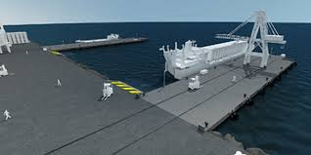
There are two docks in Izmir port. Each dock has a dedicated crane to unload the containers from the ships. The ships arrive at Izmir port in a random manner such that the inter-arrival times can be represented EXPO( 8.3) hours. When a ship arrives, it should wait onshore until a dock is available. When the ship is moored to a dock, the crane begins immediately unload the containers from the ship. Unloading time is TRIA (5, 9, 15) minutes. The ships carry different numbers of container depending on their size. A preliminary analysis shows that it can be represented via UNIFORM ( 50, 300) containers.
The discharge area on which the containers are unloaded from the ships has limited capacity such that you can stack 750 containers maximum. If space is not available, then unloading operation should be stopped.
The containers are moved out of the port by tracks each carrying only one container. Two small cranes are used to load the container onto the trucks. Loading time is 3 minutes fixed. There are only 30 trucks to be used. Each truck takes a container and moves it to a factory outside the city. The travelling time of a truck that goes to factory, unload the container and come back to the port is NORMAL ( 40, 5) minutes.

